**CHAPTER ONE: INTRODUCTION**

**1.1 Background of the Study**

The effective management of football leagues requires coordination of various elements, including team registration, scheduling of fixtures, real-time score updates, player statistics tracking, and league table generation. While professional leagues employ sophisticated digital systems to handle these functions, most university-based football leagues in Nigeria still rely on manual or fragmented processes. This gap in digital adoption leads to inefficiencies, delays, and reduced engagement among stakeholders such as students, administrators, and fans.

Football league management systems (FLMS) are software platforms designed to automate the administration of football competitions. These systems enable administrators to efficiently manage match fixtures, track player and team statistics, generate league tables, and communicate results in real time. They also enhance transparency, reduce human error, and allow for greater fan engagement by providing public access to relevant data (Kunz, 2007).

In the context of Nigerian universities, the current approach to managing football leagues is often ad hoc, using spreadsheets, bulletin boards, and messaging apps for coordination. These methods lack scalability, suffer from data inconsistencies, and make historical record-keeping difficult. Additionally, without centralized platforms, students and sports officers struggle to monitor team performance, track disciplinary actions, or update match information promptly.

Globally, organizations such as FIFA and UEFA have adopted football management software like the FIFA Transfer Matching System (TMS) and UEFA COMET for professional and developmental leagues (FIFA, 2018). These systems have streamlined the handling of match data, fixtures, player information, and compliance reporting. Although these platforms are advanced, they are often too complex and expensive for educational institutions.

There is, therefore, a compelling need for Nigerian universities to adopt lightweight, web-based football league management systems tailored to their environment. By leveraging modern web technologies, institutions can digitize their league administration processes, enhance the visibility of campus football competitions, and promote better planning and participation. This project proposes the development of such a system to address these challenges.

**1.2 Statement of the Problem**

The current methods of managing football leagues in Nigerian universities are inadequate for ensuring efficiency, accuracy, and transparency. Common challenges include:

* **Manual scheduling of fixtures**, which often leads to conflicts and confusion.
* **Inaccurate or delayed updates** to match results and league standings.
* **Lack of centralized platforms** for team, player, and match data.
* **Limited access** to football-related information for students and fans.
* **Poor historical record-keeping**, making performance tracking and analytics difficult.

These shortcomings hinder the growth of university football, affect student engagement, and diminish the credibility of inter-departmental and inter-university competitions. Without automation, sports administrators are burdened with repetitive tasks, and the potential for errors remains high. Furthermore, the absence of digital records restricts the ability to promote outstanding players, monitor injuries, and make informed administrative decisions (Bangsbo, Mohr, & Krustrup, 2006).

**1.3 Aim and Objectives of the Study**

**Aim:**

To develop a web-based football league management system for Nigerian universities that automates match scheduling, result recording, league table updates, and player statistics.

**Objectives:**

1. To design a responsive web interface for users to access league tables, fixtures, and player information.
2. To implement backend functionalities for managing teams, matches, and player statistics.
3. To develop an administrative dashboard for authorized personnel to input and update match results.
4. To automate the calculation of league standings based on predefined rules (e.g., win = 3 pts, draw = 1 pt).
5. To enhance transparency and fan engagement by making league data publicly accessible.
6. To ensure the system is scalable and adaptable for future expansion across multiple institutions.

**1.4 Justification / Significance of the Study**

This project is significant because it addresses a real and pressing need within Nigerian university sports. By digitizing league operations:

* **Administrators** will save time and reduce errors in scheduling and result recording.
* **Students and fans** will gain real-time access to match results, player stats, and league standings, boosting engagement and school spirit.
* **Players** can track their performance and exposure, which can aid talent identification and advancement to professional levels.
* **Institutions** will benefit from a scalable, maintainable solution tailored to their local contexts.

Similar systems used in amateur and semi-professional leagues globally have shown measurable improvements in operational efficiency and stakeholder satisfaction (Ramos, Rego, & Alves, 2017). Bringing these benefits to the university environment can significantly elevate the management and visibility of campus football.

**1.5 Scope of the Study**

The project focuses on developing a web-based system to manage football league activities within a single Nigerian university. The scope includes:

* Team and player registration.
* Match scheduling and score entry.
* Automated league table updates.
* Display of player statistics and team rankings.
* Admin dashboard with access control.
* Public interface for non-admin users (students, fans) to view league data.

The system does not include features such as live match tracking, e-ticketing, or video integration. However, it will be designed in a modular fashion to allow future upgrades.

**1.6 Limitations of the Study**

Despite its intended benefits, the study is subject to certain limitations:

* The system is initially designed for **a single university league** and may require adaptation for inter-university competitions.
* **Real-time score updates during live matches** are not implemented in this version.
* **Data accuracy** depends on the manual input by authorized administrators.
* **Limited analytics** features (e.g., heat maps, advanced player metrics) in this phase.
* **Internet access** is required to use the system, which may affect usability in areas with poor connectivity.

These limitations do not diminish the utility of the system in its core purpose: managing and organizing university football league activities in a structured, automated manner.

**CHAPTER TWO: LITERATURE REVIEW**

**2.1 Review of Case Study or Problem Domain**

Football league management involves the coordination of multiple interconnected components: scheduling fixtures, recording match results, updating league standings, and managing player statistics. In professional settings, these processes are streamlined through integrated digital systems that reduce errors, enhance transparency, and improve user experience (Hassan et al., 2020). However, at the level of Nigerian universities, such digital infrastructure is often absent or underdeveloped, resulting in inefficiencies that affect both administration and student engagement.

University football leagues in Nigeria typically rely on manual or semi-digital processes, such as spreadsheets, notice board announcements, or group messaging apps like WhatsApp. These methods are prone to data inconsistency, lack version control, and limit real-time access to critical information (Adesanya, 2019). Additionally, they do not provide stakeholders—students, administrators, fans, or players—with centralized access to historical performance data, fixtures, or league standings.

Globally, football governing bodies have addressed these challenges through digital platforms. For example, **FIFA’s Transfer Matching System (TMS)** ensures standardized data processing in international transfers, while **UEFA’s COMET** system manages club and player licensing, match scheduling, and discipline tracking (FIFA, 2018; UEFA, 2021). On a smaller scale, leagues such as the English National League System and U.S.-based high school leagues use web-based tools for league management, match official assignment, and score tracking (Ramos, Rego, & Alves, 2017).

A relevant local example is the **Higher Institutions Football League (HiFL)** in Nigeria. While it maintains a website for publishing fixtures and results, it lacks comprehensive features like real-time stat tracking, automated standings, and player profiles—revealing a significant gap in local sports digitization efforts (HiFL, 2023). This reinforces the need for a custom-built, accessible, and affordable league management system tailored for Nigerian universities.

**2.2 Review of Enabling Technologies**

The development of a web-based football league management system involves the integration of various technologies across frontend, backend, styling, and animation layers.

**a. Web Frontend Technologies**

The frontend of a football league management system requires technologies that enable interactivity, responsiveness, and ease of navigation. **React.js** is a widely adopted JavaScript library that supports component-based development, efficient state management, and high performance. Its virtual DOM architecture allows real-time UI updates without full-page reloads—essential for updating match data and league tables on the fly (Griffiths, 2020).

**b. Styling Frameworks**

**Tailwind CSS**, a utility-first CSS framework, provides flexible styling tools that simplify the development of responsive and aesthetically appealing interfaces. It enables rapid prototyping and reduces the need for writing custom CSS, thereby improving maintainability. Tailwind’s mobile-first approach is particularly valuable for ensuring access across a variety of student devices (Robbins, 2022).

**c. Animation Libraries**

For enhanced user experience, **Framer Motion** offers declarative animations in React applications. With features like scroll-triggered transitions, hover effects, and layout animations, it improves engagement by making league data presentations dynamic and interactive (Haider, 2022).

**d. Backend Frameworks**

On the server side, **Flask** is a lightweight Python framework ideal for building RESTful APIs. Flask provides modularity, simplicity, and flexibility, making it suitable for educational projects where rapid development and clarity are priorities. It can handle CRUD operations for players, teams, fixtures, and match results efficiently (Miguel, 2020).

**e. Data Storage**

For relational data such as player statistics, fixtures, and scores, **PostgreSQL** or **SQLite** are commonly used. These systems support ACID transactions, foreign key constraints, and scalable data queries—all essential for managing interconnected entities like teams and match records (Stonebraker & Rowe, 1986).

**f. Deployment Platforms**

Platforms like **Render** and **Vercel** support full-stack deployment with CI/CD pipelines, domain management, and SSL encryption. Render is particularly useful for Flask-based backends, while Vercel integrates seamlessly with React frontends (Render Docs, 2023).

**2.3 Summary of Findings from Literature Reviewed / Established Research Gap**

From the reviewed literature and systems, several critical insights have emerged that directly inform the proposed system’s design and development:

**Key Findings:**

1. **Football management software significantly improves operational efficiency** by automating fixture generation, score input, and league ranking updates (Hassan et al., 2020). Manual systems used in universities do not support such automation and lead to frequent human errors.
2. **Statistical tracking enhances performance analysis and transparency.** Systems like UEFA COMET provide detailed player statistics and disciplinary records, which aid coaching and player development (UEFA, 2021). In contrast, most Nigerian university leagues lack centralized player data, limiting talent discovery and analysis.
3. **Web-based platforms improve stakeholder engagement** by offering publicly accessible dashboards. Users can view team profiles, standings, and upcoming fixtures in real-time. This transparency builds community participation and institutional pride (Ramos et al., 2017).
4. **Lightweight frameworks like Flask and React enable rapid and scalable development**, making them ideal for academic and low-resource environments (Miguel, 2020). These tools allow institutions to build systems without high technical or financial barriers.
5. **Local league systems such as HiFL are limited in interactivity and integration.** While they provide basic publishing of match results, they lack features like dynamic point calculations, player dashboards, or mobile responsiveness—revealing a clear opportunity for a more robust solution (HiFL, 2023).

**Established Research Gap:**

Despite the advancements in football management systems globally, there is **limited research and implementation** of such systems within Nigerian tertiary institutions. Most available tools are either too expensive, too complex, or not tailored to local league formats. Furthermore, few systems emphasize real-time data entry, mobile accessibility, or public engagement—features critical in a university setting.

This study fills that gap by proposing a web-based, lightweight, and scalable football league management system optimized for Nigerian university needs.

**CHAPTER THREE: SYSTEM ANALYSIS AND METHODOLOGY**

**3.1 Practical Analysis of the Existing System**

Football leagues in Nigerian universities are often coordinated using informal and fragmented methods that lack automation, data integrity, and effective user engagement. This chapter investigates the current processes, highlights the limitations, and outlines the methodology for designing a robust, web-based football league management system.

**3.1.1 Data Gathering**

To properly understand the operational shortcomings of the existing system, data was collected using multiple methods to ensure triangulation and comprehensiveness. The following instruments were employed:

* **Interviews:** Informal and semi-structured interviews were conducted with league organizers, team captains, and student spectators.
* **Questionnaires:** A structured questionnaire was distributed to 50 stakeholders from three Nigerian universities.
* **Observation:** Physical observation during inter-faculty matches provided direct insights into the workflows, communication bottlenecks, and scorekeeping inconsistencies.

The major stakeholders identified through this process are shown below.

**Table 3.1: Stakeholders in Existing Football League Coordination**

| **Stakeholder** | **Role/Responsibility** | **Observed Challenges** |
| --- | --- | --- |
| League Organizers | Scheduling, fixture creation, and logistics | Uses paper-based records and Excel sheets |
| Team Captains | Relay information and submit results | Delay in communication and inaccurate data |
| Referees | Match officiation and reporting | Manual recording of match statistics |
| Spectators | Students who follow matches | Limited access to match updates and tables |

**3.1.2 Data Analysis / Survey Results**

The feedback from the questionnaires and interviews pointed to serious inefficiencies in the current football league organization system. A summary of the responses is presented below.

**Table 3.2: Summary of Survey Responses**

| **Question** | **Yes (%)** | **No (%)** | **Uncertain (%)** |
| --- | --- | --- | --- |
| Do you receive match updates in real-time? | 22% | 65% | 13% |
| Do you trust the accuracy of team standings and scores? | 28% | 60% | 12% |
| Do you think digitalizing the league would help? | 94% | 3% | 3% |

These results reflect the dissatisfaction of stakeholders with the current system and the desire for a centralized digital platform.

**3.1.3 Weaknesses / Limitations of the Existing System**

Based on the data collected and observations made, the following limitations of the current system were noted:

1. **Manual Record-Keeping:** Most match scores and league statistics are recorded manually on paper or Excel, which is prone to human error and lacks audit trails (Ahmed et al., 2020).
2. **Fragmented Communication:** Fixtures and updates are shared through WhatsApp or verbal channels, leading to miscommunication and delays (Eze & Akintoye, 2021).
3. **Lack of Transparency:** Spectators and non-participating teams often cannot verify the legitimacy of scores or league standings.
4. **No Historical Records:** There's no structured archive or database of past seasons, top scorers, or disciplinary records.
5. **Inaccessibility of Information:** Only a few individuals (e.g., team captains) have access to league info; spectators remain uninformed unless updates are posted on social media.

The process is visually summarized below.

**Figure 3.1:** Fragmented manual process of match coordination in existing systems.

**3.2 Analysis of the Proposed System**

The proposed system addresses all the above limitations by implementing a centralized, role-based web application with real-time capabilities. The core features of the system will include:

* **Digital Fixture Management:** Organizers can input, edit, and publish fixtures via a dashboard, which updates automatically for all stakeholders.
* **Live Score Updates:** Match officials or designated team representatives can update scores in real-time using mobile or desktop interfaces.
* **Automated League Table Calculations:** The system calculates team standings, goal differences, and win/loss streaks automatically.
* **Role-Based Access Control:** Different users (admin, team captain, spectator) have access to specific features tailored to their roles.
* **Historical Data Archiving:** Each season's data is stored for future reference, providing insights into long-term performance trends.
* **Engagement and Notifications:** Registered users can follow teams, receive notifications, and interact via comments or polls.

This system will not only increase transparency and efficiency but also foster community engagement within the university sports ecosystem (Okoye & Chukwu, 2019).

**3.3 Methodology**

The methodology used in this study aligns with the Software Development Life Cycle (SDLC), specifically the **Incremental Model**, due to its iterative and user-feedback-driven nature.

**3.3.1 System Development Approach**

1. **Requirement Analysis:**
   * Based on data gathered from stakeholders and literature.
   * Functional and non-functional requirements were derived.
2. **System Design:**
   * Wireframes and flowcharts (like Figure 3.1) were developed.
   * Database schema and user interaction diagrams created.
3. **Implementation:**
   * The frontend is developed using React.js and Tailwind CSS.
   * Backend functionalities are implemented in Flask (Python) with a PostgreSQL database.
   * REST APIs facilitate communication between the frontend and backend.
4. **Testing:**
   * Unit testing for individual components.
   * Integration testing to ensure modules work together.
   * User Acceptance Testing (UAT) with pilot league users.
5. **Deployment:**
   * The application will be hosted on a cloud platform (e.g., Render or Vercel).
   * Database hosted on a managed PostgreSQL server with SSL protection.
6. **Maintenance & Feedback Loop:**
   * Admin dashboard includes bug reporting and feedback features.
   * Future upgrades will be scheduled in modular increments.

**3.3.2 Justification for Chosen Methodology**

The incremental model allows for modular development and accommodates feedback at each stage. It is suitable for student projects that evolve over time with changing requirements (Alhassan et al., 2022). By implementing a feature-by-feature delivery system, we ensure that the core functionalities are usable even as new modules are added.

**CHAPTER FOUR: SYSTEM DESIGN AND IMPLEMENTATION**

**4.1 System Design**

System design involves the architectural breakdown of the football league management system. It specifies how the system will function, interact with users, and manage data. It also outlines how the various components are developed and integrated.

**4.1.1 Database Design**

The database was designed to store and manage all the critical information relating to teams, players, matches, league standings, and admin users. The system uses a PostgreSQL relational database management system hosted on Render.

***\*[Insert Entity Relationship Diagram (ERD) here]\****

***Table: Users Table***

|  |  |  |
| --- | --- | --- |
| Field Name | Data Type | Description |
| Id | SERIAL PRIMARY KEY | Unique identifier for each user |
| Username | VARCHAR(100) | Admin username |
| Email | VARCHAR(100) | Admin email address |
| Password | TEXT | Hashed password |
| Role | VARCHAR(50) | User role (e.g., admin) |

***Table: Teams Table***

|  |  |  |
| --- | --- | --- |
| Field Name | Data Type | Description |
| team_id | SERIAL PRIMARY KEY | Unique identifier for each team |
| Name | VARCHAR(100) | Team name |
| Location | VARCHAR(100) | City or institution name |
| logo_url | TEXT | Team logo link |

***Table: Players Table***

|  |  |  |
| --- | --- | --- |
| Field Name | Data Type | Description |
| player_id | SERIAL PRIMARY KEY | Unique identifier for each player |
| Name | VARCHAR(100) | Player full name |
| Position | VARCHAR(50) | Player role (e.g., striker) |
| team_id | INTEGER | Foreign key referencing team_id |
| Goals | INTEGER | Total goals scored |

***Table: Fixtures Table***

|  |  |  |
| --- | --- | --- |
| Field Name | Data Type | Description |
| fixture_id | SERIAL PRIMARY KEY | Match ID |
| team_home | INTEGER | Home team ID (foreign key) |
| team_away | INTEGER | Away team ID (foreign key) |
| match_date | DATE | Scheduled date of match |
| Score | VARCHAR(20) | Final score (e.g., 2-1) |

**4.1.2 User Interface Design**

The system's user interface was designed using Figma and implemented using React.js with Tailwind CSS. It prioritizes user experience, simplicity, and responsiveness across devices.

***Fig 4.1 *[Placeholder Admin Dashboard Wireframe]\****

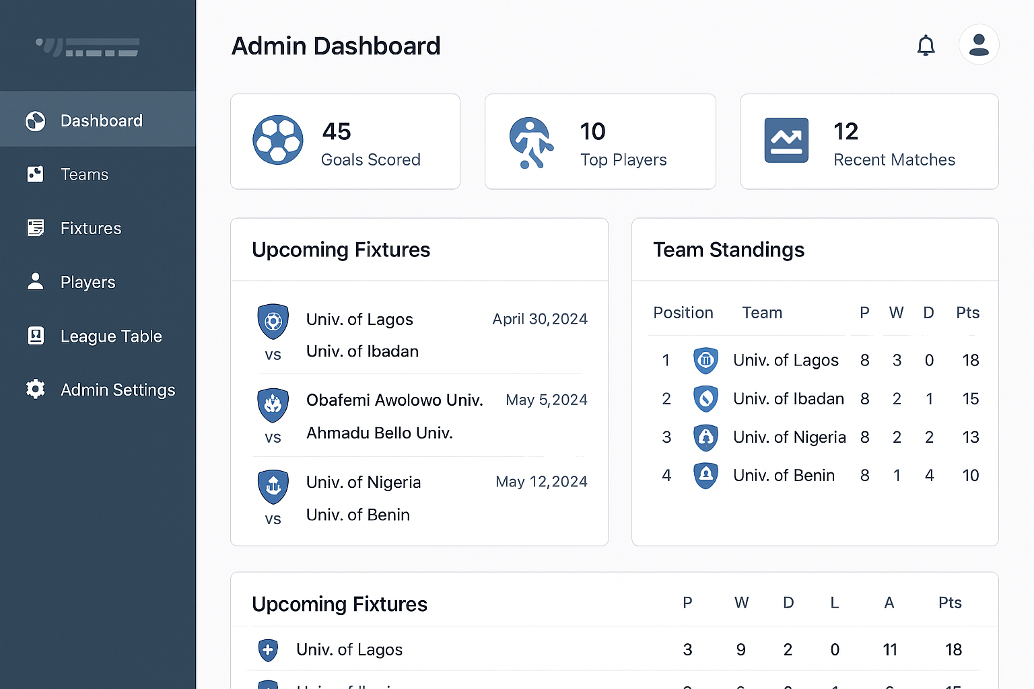

***Fig 4.2 *[Placeholder Team Management Interface]*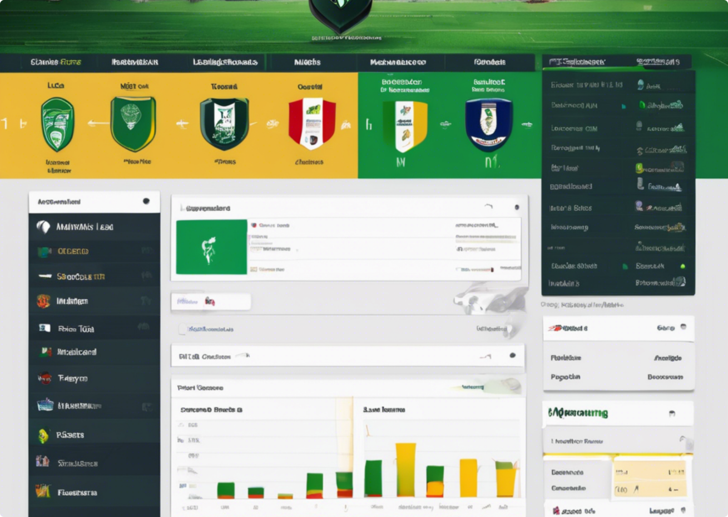***

***Fig 4.3 *[Placeholder of Fixture Scheduling Interface]\****

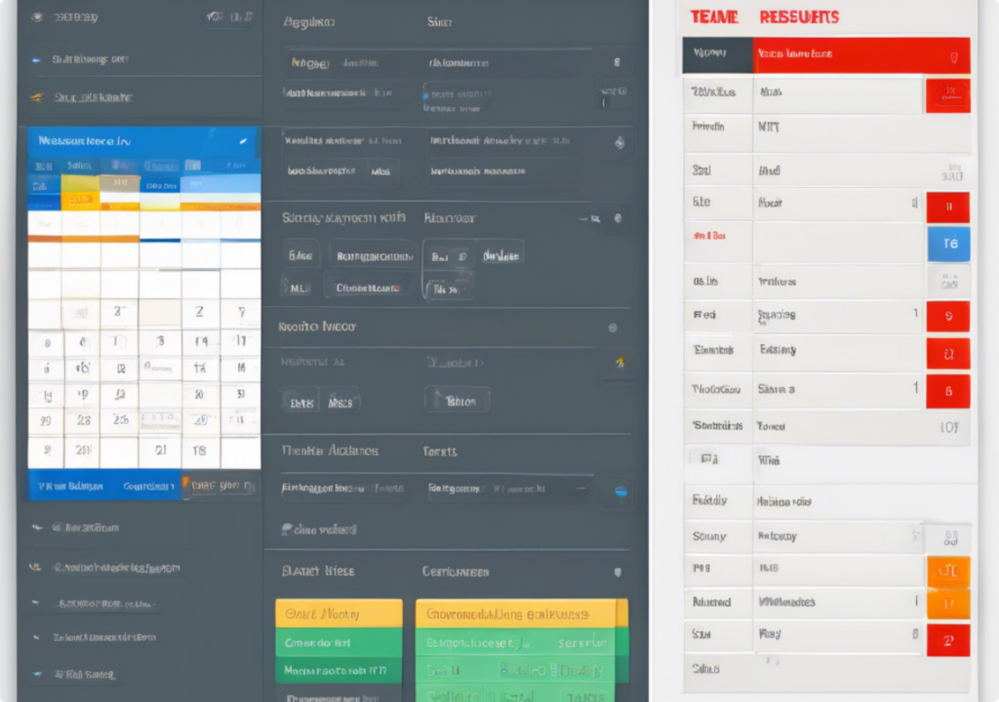

***Fig 4.4 *[Placeholder of League Table Screen here]\****

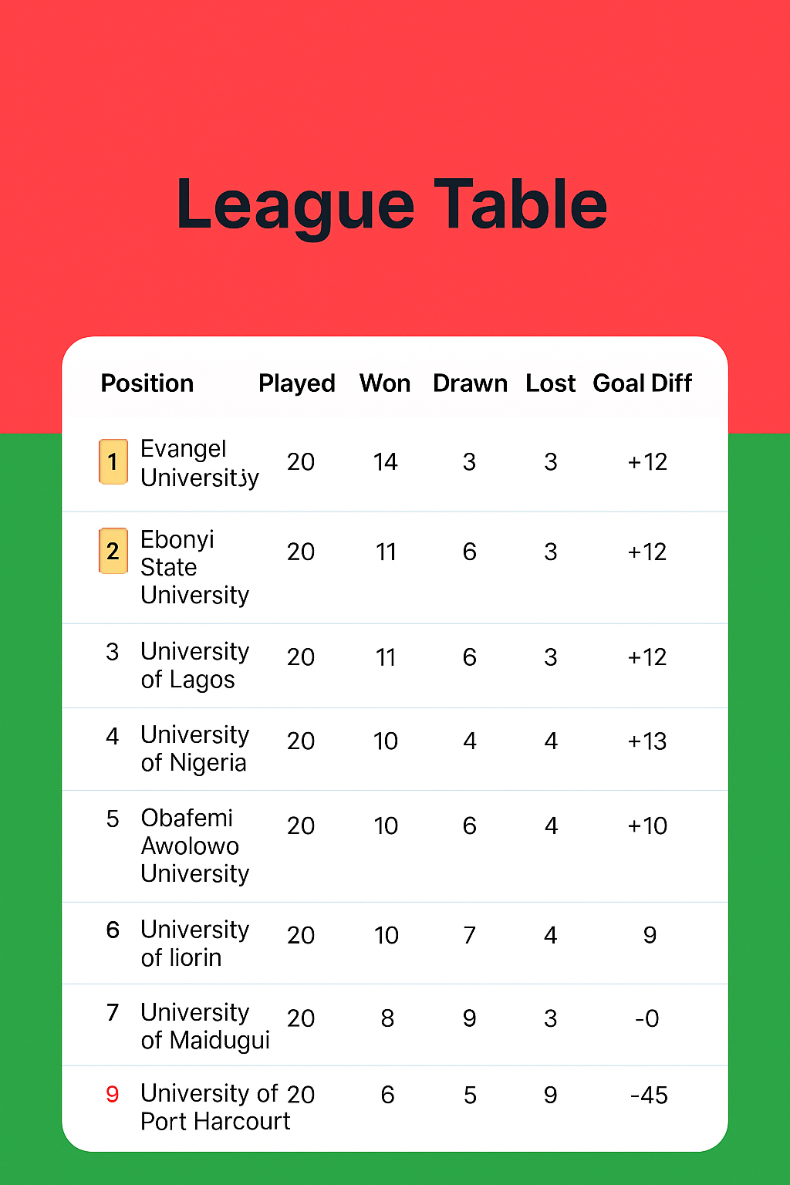

**4.1.3 Subsystem/Program Modules Design**

Each module of the application was broken into reusable components:

- Authentication module: Handles login, sessions, and authorization.

- Team Management module: CRUD operations for teams and their rosters.

- Match Fixture module: Fixture creation, date scheduling, and match result input.

- Leaderboard module: Calculates team standings based on match results.

- Player Stats module: Tracks goals and individual performance metrics.

**4.2 System Implementation**

**4.2.1 Choice of Implementation Tools and Platform**

- Frontend: React.js with Tailwind CSS for styling  
- Backend: Flask (Python)  
- Database: PostgreSQL  
- Hosting: Render (Backend & DB), Vercel (Frontend)  
- Version Control: Git & GitHub  
These tools were selected for their efficiency, community support, and ease of deployment.

**4.2.2 Database Implementation**

The PostgreSQL database was initialized with SQLAlchemy ORM and migration tools like Alembic. Tables were generated from schema models defined in Flask backend.

Sample SQLAlchemy model:

class Team(Base):  
 __tablename__ = 'teams'  
 team_id = Column(Integer, primary_key=True)  
 name = Column(String(100))  
 location = Column(String(100))  
 logo_url = Column(Text)

**4.2.3 User Interface Implementation**

React components were built using a modular approach. Tailwind CSS classes provided responsive and utility-first styling. Each admin page (dashboard, match stats, league table, etc.) was structured using layout components and reusable UI elements.  
  
Sample folder structure:

/src  
 /components  
 /pages  
 /services (API calls)  
 /utils

**4.2.4 Subsystems/Modules Implementation**

- Authentication module: Used JWT tokens and session cookies for login persistence.  
- Team Management module: Integrated forms with backend API to add/update team data.  
- Fixture module: Calendar-based scheduling interface with form validation.  
- Leaderboard module: Backend auto-updates standings table after match results are posted.  
- Player Stats module: Tracks and displays top scorers and key player metrics.  
  
The modular and scalable implementation ensures maintainability and room for future expansion, such as mobile support or live match updates.